The purpose of the project is to observe whether alcohol will have an effect on the participants heart rate variability, by causing it to increase or decrease, or not affect it at all. Subjects were first tested under no additional ‘Stress’ as a control. Subject 1’s control data can be seen below.

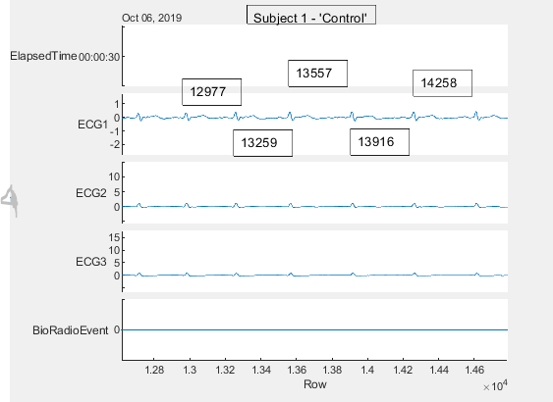

Figure 1: Subject 1 Control Test

After the subject’s control was measured, they were sent to consume 16 oz of ‘Molson Canadian’ which has an alcohol percentage of 5%. The subject’s had 20 minutes to complete the beverage and then were brought back up to the lab. After a 5 minute cool down period was over, the subject was tested again. Subject 1’s after beverage results can be seen below.

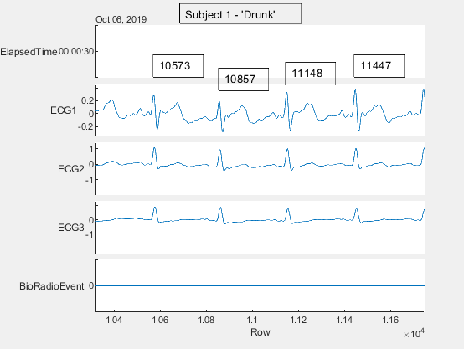

Figure 2: Subject 1 after Beverage